Hesham Omar Mahmoud 202000060

1.

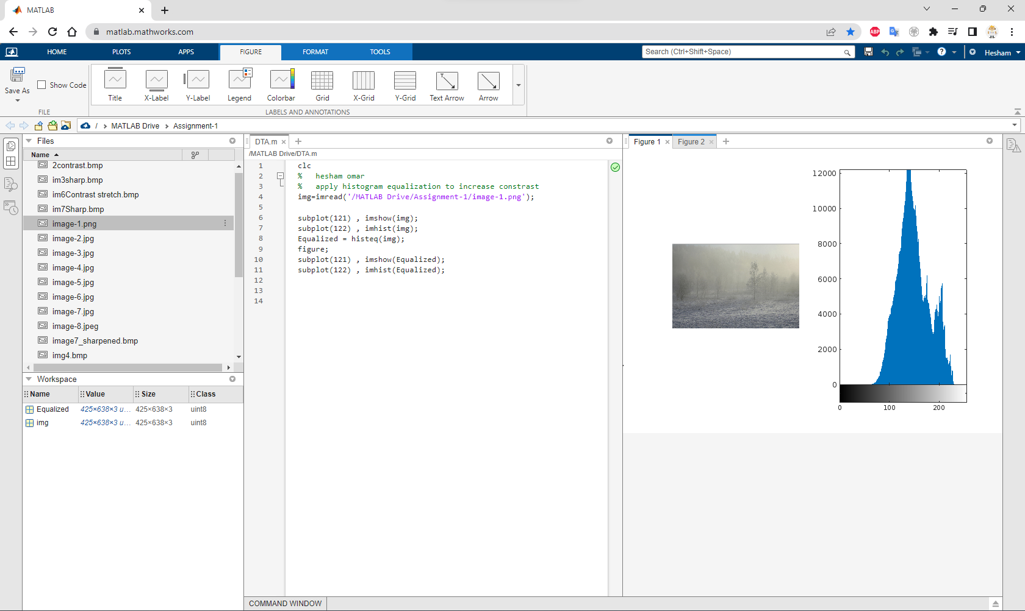

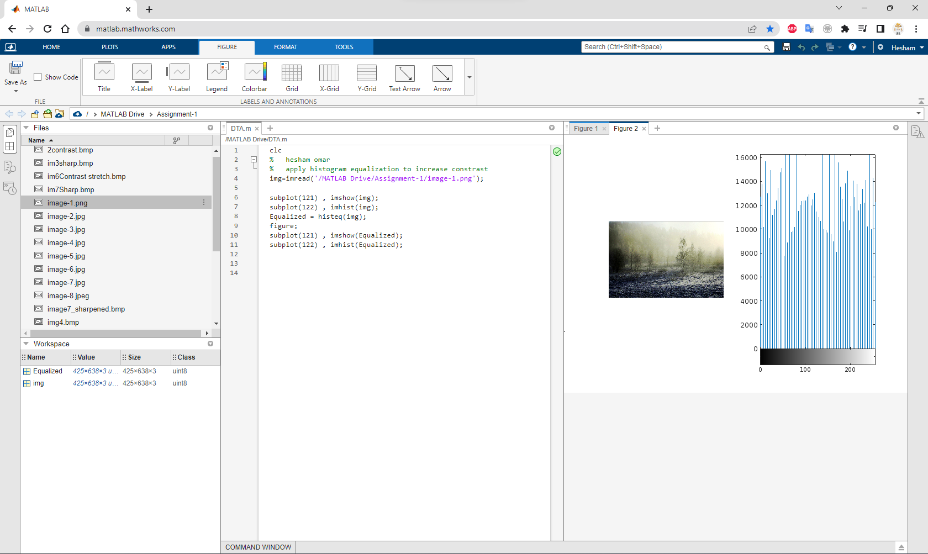

Image has low contrast, I applied histogram equalization to increase contrast.

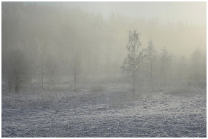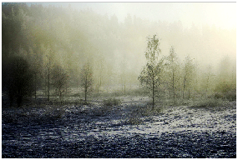

2.

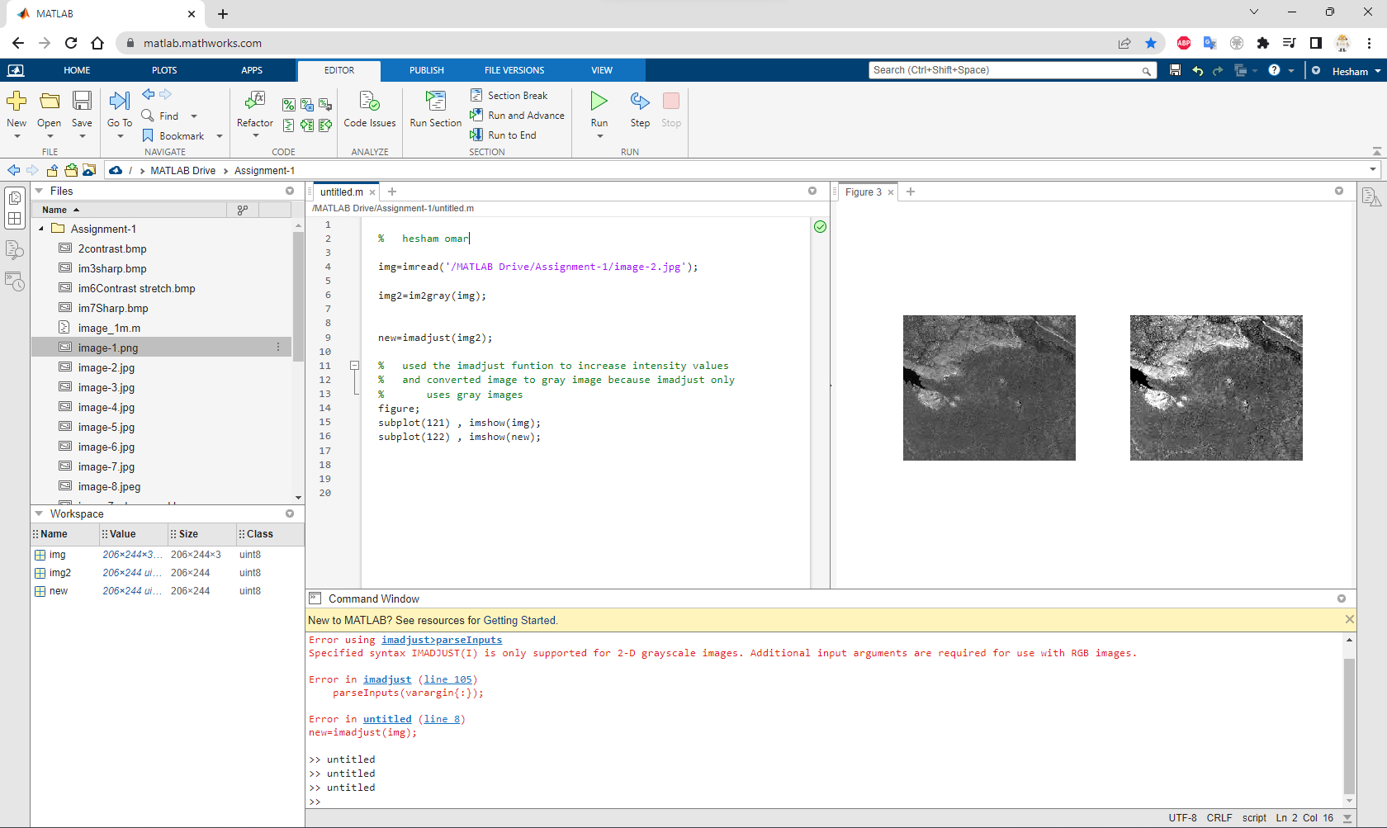

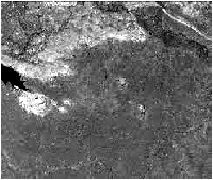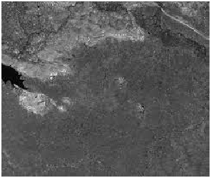

I used the ‘imadjust’ function to increase intensity values, and converted image to gray image because ‘imadjust’ only accepts gray images.

3.

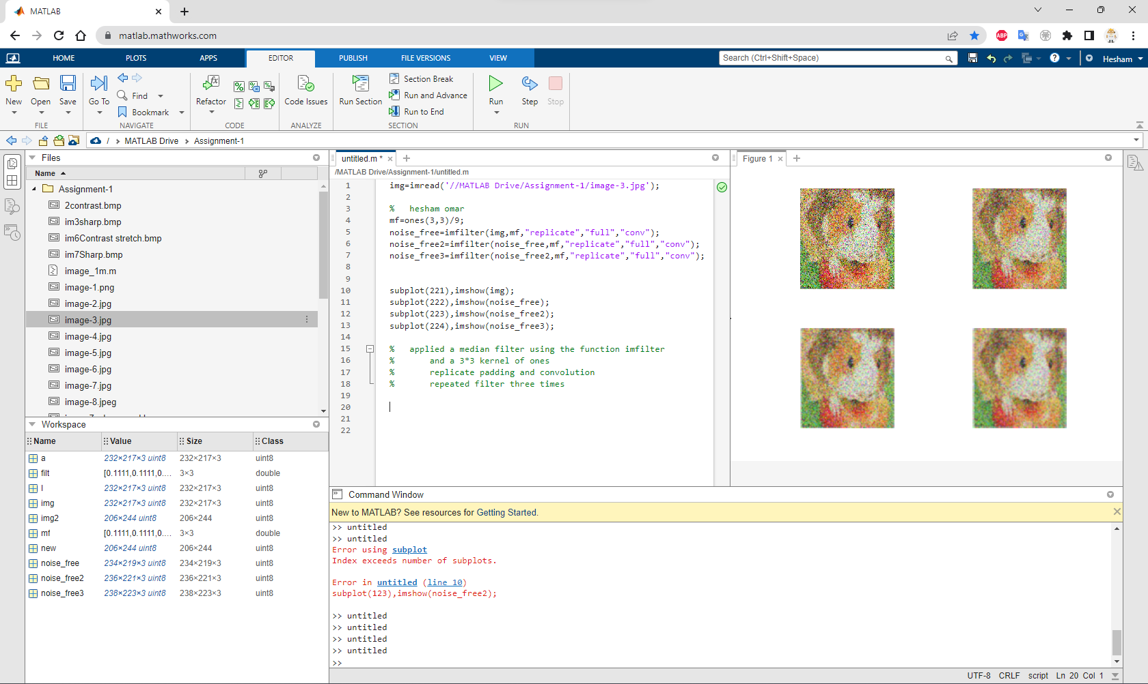

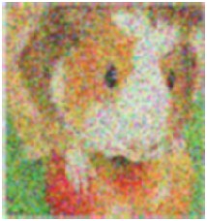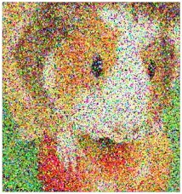

Applied a median filter using the function ‘imfliter’ and a 3\*3 kernel of ones, used replicate padding and convolution when using the kernel, and I repeated filtering 3 times.

4.

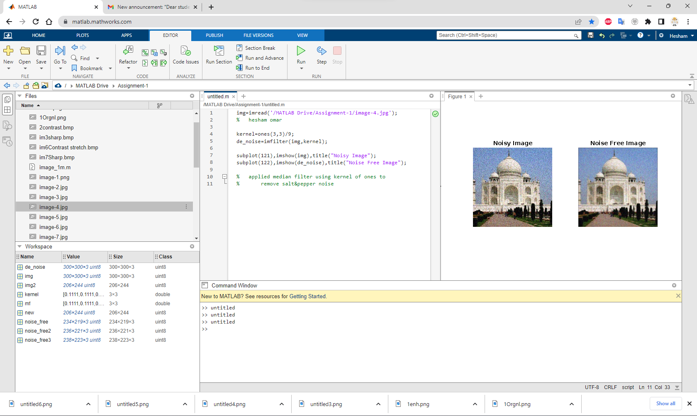

Applied median filter to remove salt & pepper noise.

5.

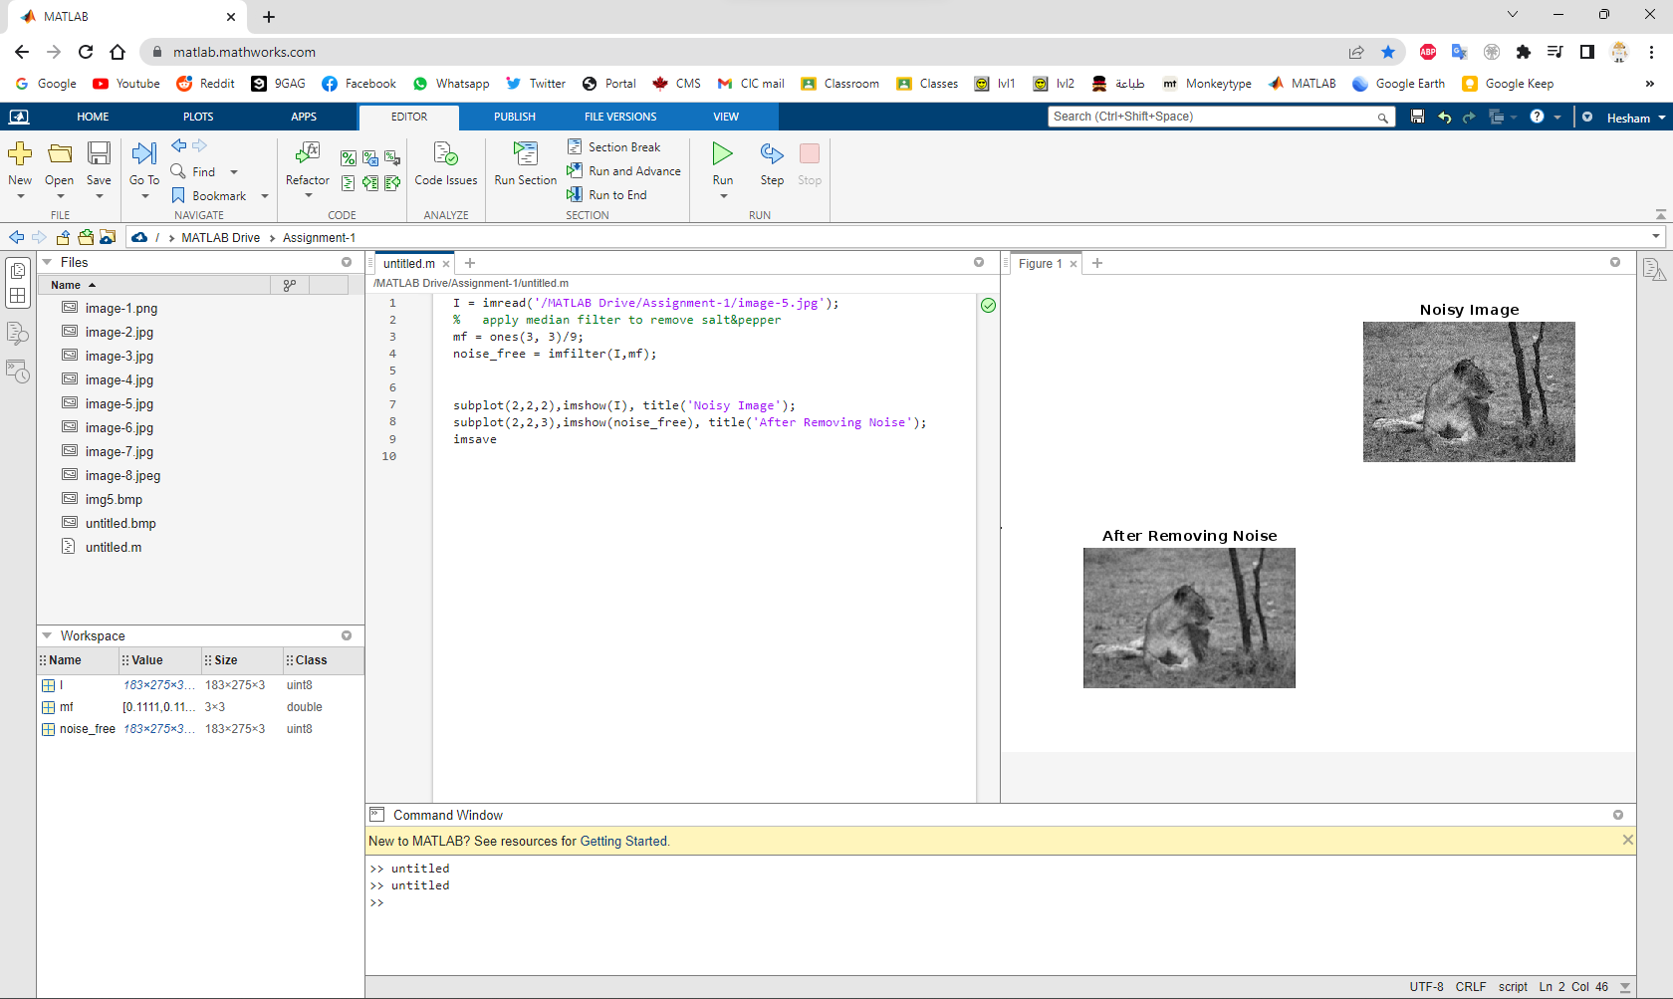

Applied median filter to remove S&P noise.

6.

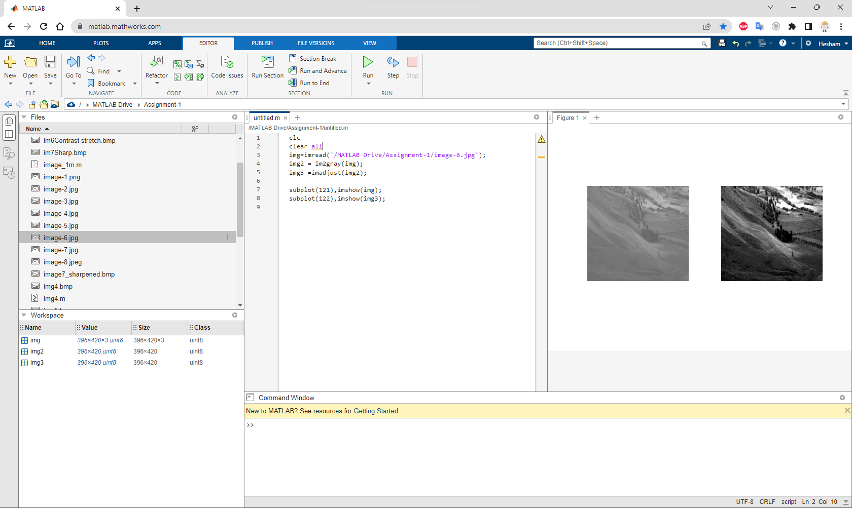

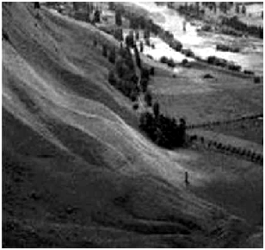

Similar to image 2 I used the ‘imadjust’ function to increase intensity values, and converted image to gray image because ‘imadjust’ only accepts gray images.

7.

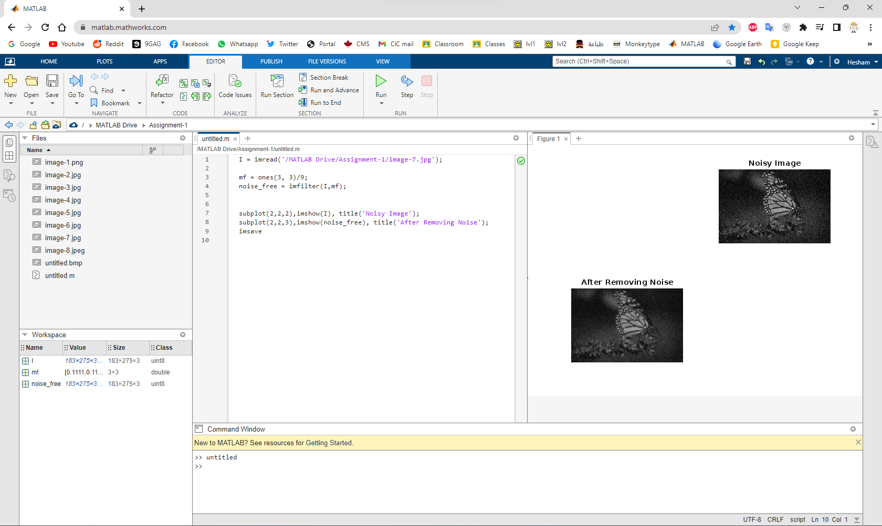

Removed S&P noise similar to 3 and 4.

8.

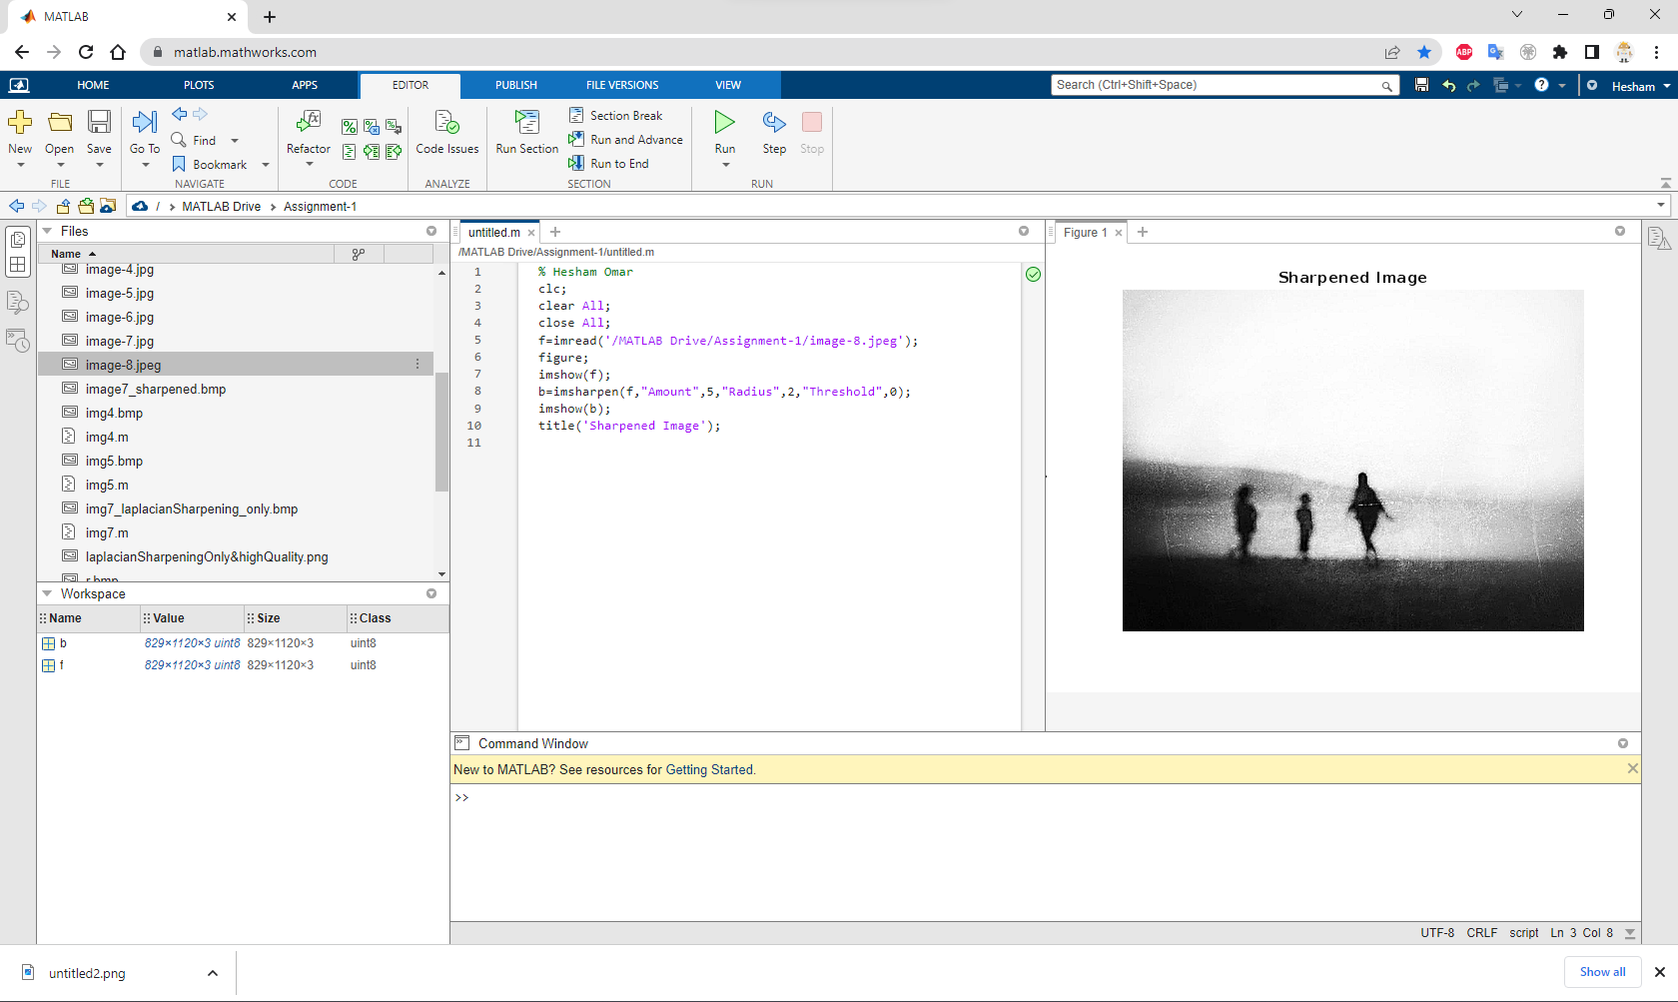

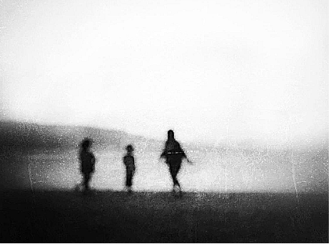

Image was blurry so I sharpened the image using the ‘imsharpen’ function with

Amount = 5

Radius = 2

Threshold = 0